Practicum Final Exam – Odd Semester Year 2021/2022
Subject |  |  | COMP6047 – Algorithm and Programming |  |  | 
Class | : | 09BB |  | Start Date | : 03 December 2021
Lecturer | : | D5387 - Harvianto, S.Kom, M.T.I. |  | Start Time | : 08.00
Lecturer | : |  |  | End Date | : 03 December 2021
Lecturer | : |  |  | End Time | : 10.00

PERATURAN UJIAN:
Exam Regulations:
- Mahasiswa tidak diperbolehkan berdiskusi dan/atau bekerja sama dengan peserta ujian lainnya
Student is not allowed to discuss and/or work together with other exam participants
- Mahasiswa tidak diperbolehkan untuk membuka dan menyalin dari BUKU atau CATATAN, VIDEO dari pengajar (recording kelas, VBL, Youtube, dsb) dan REFERENSI lainnya
Student isn't allowed to open and copy from any resources such as notes, videos (class recording, VBL, Youtube, etc) and other references
- Mahasiswa tidak diperbolehkan membuka dan menyalin jawaban dari internet (google, stackoverflow, dsb)
Student isn't allowed to open and copy answer from the internet (google, stackoverflow, etc)
- Asisten BERHAK memberi nilai 0 (NOL) bagi peserta ujian yang melakukan segala bentuk kecurangan
Assistant is able to give 0 (ZERO) score for exam participant who does any cheating actions
- Kumpulkan jawaban tepat pada waktunya, apabila terlambat mengumpulkan maka jawaban tidak akan dikoreksi dan nilai mahasiswa adalah 0
Submit the answer on time, if not, then the answer will not be checked, and the students will receive 0 (ZERO)
- Bila Anda tidak membaca peraturan ini, maka Anda dianggap telah membaca dan menyetujuinya
If you have missed to read these regulations, so you are considered to have read and agreed on it

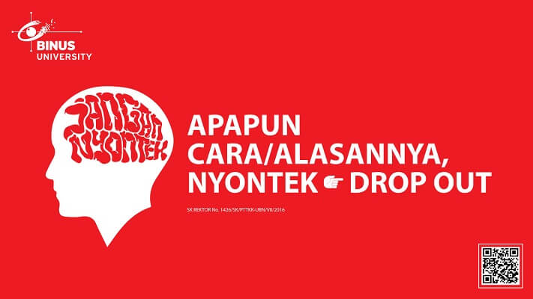

SOFTWARE YANG DIGUNAKAN:
Software will be used:
- Dev-C++ 5.11

FILE YANG DIKUMPULKAN:
File must be collected:
- CPP

PERHATIAN!
Attention!
- Bagi yang mengerjakan tidak sesuai dengan soal, maka akan diberikan nilai NOL (0)
For those who do not work in accordance with the exam case will be marked as ZERO (0)
- Bagi yang mengerjakan tidak sesuai dengan software dan versi yang telah ditetapkan, maka akan tetap dikoreksi dengan software dan versi yang telah ditetapkan
For those who do not work in accordance with the software and specific version will be corrected by the predefined software and version
- Kompres semua jawaban yang akan diunggah. Pastikan format pengumpulan nama file dan ekstensi sesuai dengan format berikut: [NIM]-[NAMA].zip
Compress all file that will be uploaded. Make sure the format for collecting file name and extension according to the following format: [NIM]-[NAME].zip

Important Notes:
- Do not code only on the main function, each menu must be separated into a separate function
- You need to use Merge Sort/ Quick Sort Algorithm
- You are allowed using a struct to store all your variable that needed

Soal
Case
ShoPAI
ShoPAI is new startup created by NiKo that sells a variety of items. You as a programmer is hired by NiKo to build a program to help the startup manage the incoming items and item orders. Your task is to create a program using C Programming Language based on the description below:
- In the first time, the program will read the file which the name is ‘ShoPAI.txt’ using the following format:
Code/Name/Type/Price/Quantity
- If the file does not exist, do not insert any data.
- If the file exists, but there are no content inside it, do not insert any data.
- If the file exists and there are contents inside the file, insert the data and stored it in an array.
- The program consists of 4 menus:
- Add new menu
- View menu
- Purchase
- Exit
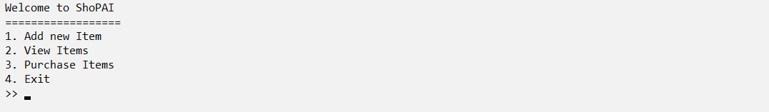
Figure 1. Menu

- The program will ask the user to input the chooses menu, which must be between 1 and 4
Figure 2. Menu Validation
- If the user chooses menu 1 (‘Add new Item’), then:
- The program will ask the user to input menu details, which consists of:
- Item Type, which must be between 1 and 3
- Item Name, which length must between 5 and 20 characters
- Item Price, which must be between 15000 and 300000
- Quantity, which must be more than 0
- If the inputs are valid, generate Menu Code using following formula:
Format: XX-YYY-ZZ
XX first 2 characters from Item Name with the uppercase format
Y random number between 0 and 9
Z random alphabet from A - Z
Example:
Menu Name | Nerf Gun
Random Number 1 | 3
Random Number 2 | 7
Random Number 3 | 2
Random Alphabet 1 | G
Random Alphabet 2 | J
Menu Code: NE-372-GJ
- Add the data to an array and show the message ‘Data added Succesfully’
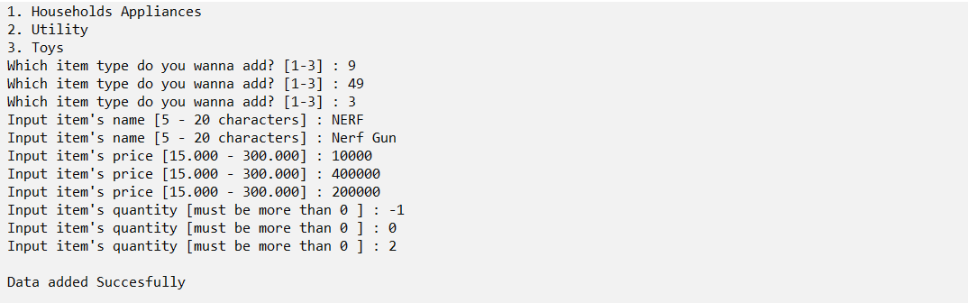
Figure 3. Insert Menu
- If the user chooses menu 2 (‘View Items’), then:
- The program will ask the user to input Menu that wants to view, which must be between 1 and 5
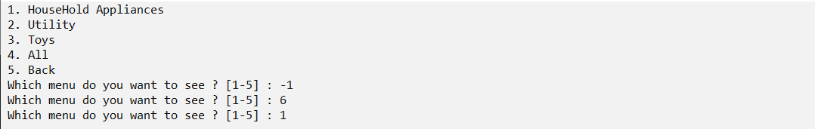
Figure 4. View Menu
- If the user chooses a menu between 1 and 3, then show the item list according to the selected item type
- If the user chooses menu 4, then show all the item list.
- If the user chooses menu 5, then get back into the previous form
- If the selected list is empty, then show the message ‘No data Available’
Figure 5. No Data Message
- Otherwise, show the sorted data based on Item Name with descending order.
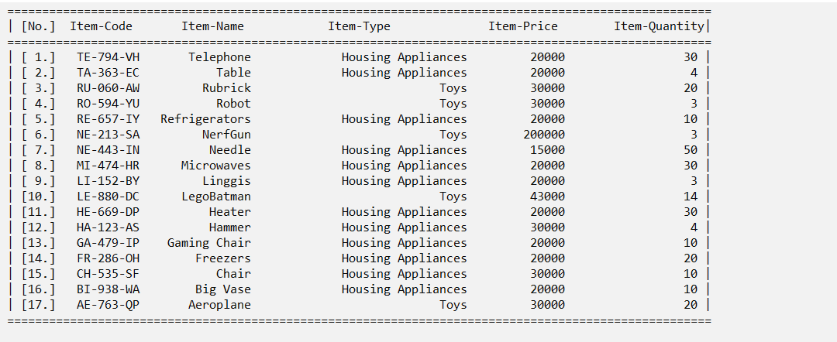
Figure 6. View Item List
- If the user chooses menu 3 (‘Purchase’), then:
- If the list is empty, then show the message ‘No data available’
Figure 7. No Data Message
- Otherwise:
- The program will ask the user to input the Item that the user wants to purchase.
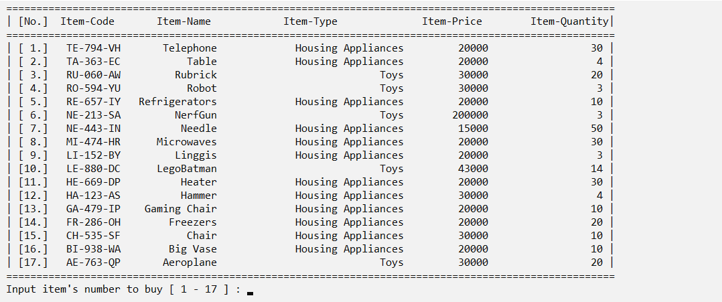
Figure 8. Select Item to be Deleted Menu
- If the user chooses the item, but the item quantity is 0 then the program will show the message that this item is sold out.
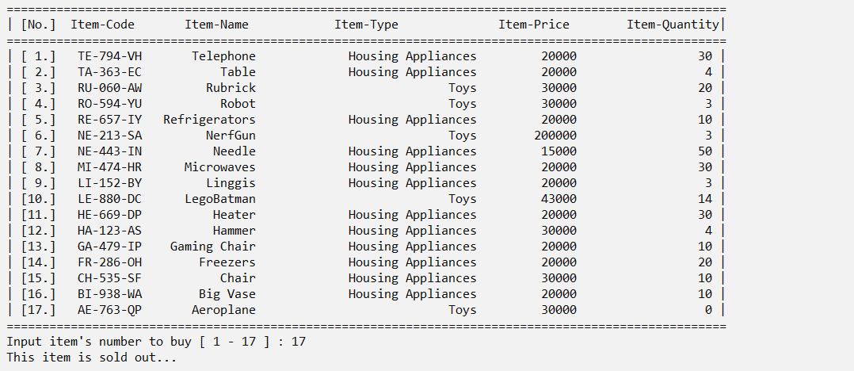
Figure 9. Sold Out Item Message
- If the item quantity isn’t 0 then ask for the details such as:
- Item Quantity, which cannot be more than the available quantity
- Subtract the available Item-Quantity with the quantity inputted by the user
- Ask if the user wanted to purchase another item which must be either ‘Yes’ or ‘No’ (case sensitive)
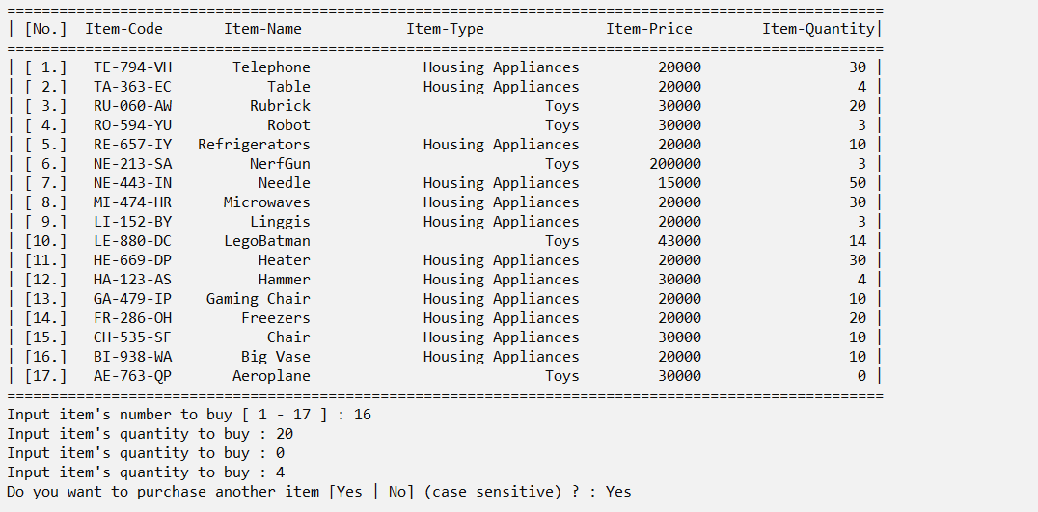
Figure 10. Purchase More
- If the user chooses ‘Yes’, then the program will refresh the page, and ask again to input Item that the user want to purchase
- Otherwise:
The program will show the bill payment
- The bill payment will show the details of payment which consist of Item Code, Item Name, Quantity, Item Price, Subtotal, Total Items, Total Price, Tax (10%), and Grand Total Price
- The Subtotal, Total Item, Total Price, Tax (10%), and Grand Total Price obtained using the following formula:
Subtotal = Quantity * Menu Price

Quantity [1]
Quantity [2]
Quantity […]
Quantity [n]
--------------------------------------------- +
Total Item

Subtotal [1]
Subtotal [2]
Subtotal […]
Subtotal [n]
--------------------------------------------- +
Total Price

Tax (10%) = Total Price * 10 / 100

Grand Total Price = Total Price + Tax (10%)
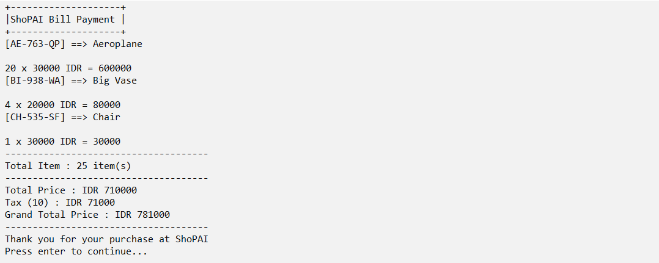
Figure 11. Bill Payment

- If the user chooses menu 4 (‘Exit’), then:
- The program will save the menu list to the file which name is ‘ShoPAI.txt’ using the following format:
Code/Name/Type/Price/Quantity
- After that, the program will be closed

Run the program for more details!

